Mẫu 1

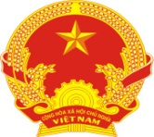  (Photo) | Socialist republic of Vietnam  Independence - Freedom - Happiness  IDENTITY CARD  No.: 012345678  Name and surname: NGUYEN VAN A  Date of birth: 22-12-1990  Homeland: District 4, Ho Chi Minh City  Permanent residence: No. 50, Street 17, Ward 4, District 4, Ho Chi Minh City

Ethnic group: Kinh - Religion: None
Fingerprint | Left index | Particular trace or deformity:  A scar at the distance of 0.2cm in front of left eyebrow
Fingerprint | Right index | Date: 11/07/2005  Director of Ho Chi Minh City’s  Public Security Department  (Signed and sealed)  Nguyen Chi Dung

Chiasetainguyen.com

Mẫu 2

SOCIALISTREPUBLIC OF VIETNAM
Independence - Freedom - Happiness

IDENTIFY CARD
No.: 012345678
Full name: NGUYEN VAN A
Date of birth: November 22nd, 1990
Native place: Ho Chi Minh City
Place of permanent: No. 50, Street 17, Ward 4, District 4, Ho Chi Minh City

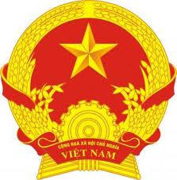

Photo

Ethnic Group: Kinh Religion: Catholicism
 | LEFT FOREFINGER | INDIVIDUAL TRACES AND DEFORMITIES
 | LEFT FOREFINGER | Mole 0.5cm under the left side of the nose
 | LEFT FOREFINGER | Dated July 11th, 2015  DIRECTOR OF HO CHI MINH’S PUBLIC SECURITY  (Signed and sealed)  Nguyen Chi Dung
 | RIGHT FOREFINGER

Chiasetainguyen.com

